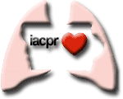
Save the Date

Reserve Room by March 1st to Receive Group Discount

IACPR Cardiopulmonary Rehab Conference
March 23rd & 24th, 2018
Holiday Inn & Suites Des Moines Northwest
4800 Merle Hay Road, Des Moines, IA 50322
To Make Reservations Call (515) 278-4755
Identify Group Discount CPR

Dedicated to Providing Education & Improving Communication Between Multidisciplinary Healthcare Professionals Who Promote Cardiovascular & Pulmonary Health.

