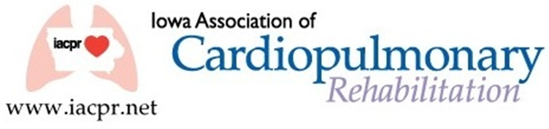

IACPR Committee Members 2022-2023
President: Eric Larson
Past President: Peg King
President Elect: Brandy Tripp
Secretary: Sharon Mays
Treasurer: Deb Anderson
Directors:
Aleshia Blocker
Lindsey DeJong
Sharon Mays
Gwen Bridgman
Michelle Henrichsen

COMMITTEE LEADERS
and
Members

Budget and Finance:
Deb Anderson (Treasurer)
Eric Larson (Director)
Communication:
Leah Lenz (Chairperson)
Sharon Mays (Director)
Education
Brandy Tripp (Chairperson)
Lindsey DeJong (Director)
Diane Callahan
Krystle Primus
Denise Promes
Eric Larson
Erika Leonard
Membership:
Michelle Litterer (Chairperson)
OPEN (Director)

Reimbursement/Legislative:
Susan Flack (Chairperson)
Aleshia Bloker (Director)

https://iacpr.net/resources/Pictures/Peg%20King.jpg

Fall 2023 Issue

President’s Message
The leaves are changing, and the air is getting brisk…another beautiful fall in Iowa. As the weather changes, so are we within the IACPR. We are so excited to announce several new opportunities for members that will be released over the next year. First and foremost, we have officially set the date for our annual state conference.
We are pleased to announce that we will have a wide array of speakers from all different backgrounds speaking this year. Secondly, we are organizing a new entity to the state, a Grassroots Initiative. This will be a day-long seminar every other fall, hosted and instructed by other experienced cardiopulmonary rehab professionals, that will help explain Cardiac and Pulmonary Rehab from A to Z. This will be intended for the professional looking to get a refresher or those individuals new to our departments that need all the basic information. More information of this to come. Finally, I am pleased to announce that we are looking for volunteers within the state to help us establish a social media presence with our members. If you or someone you work with would love to get more involved with the state and are social media savvy, we could use you. For more information just contact eric.larson@mercyoneiowa.org and we will help answer any questions.
As always, please feel free to reach out to any board members, if questions or concerns arise.
Sincerely,
Eric Larson
IACPR President

The IACPR needs member participation to survive, I am therefore putting a call out to all members of IACPR that may be interested or would like to inquire about serving on the Board, the Education Committee of IACPR or as a volunteer for our new social engagement committee. For the coming year we have several Board positions open, including President Elect. If you have ever thought of serving on the Board and wanted to make a difference, this may be your opportunity.
The Education Committee establishes content, plans, and carries out the spring conference and any other educational programs offered by IACPR. Serving on statewide committees or the board of directors for IACPR helps develop leadership skills, provides networking opportunities, and volunteering in a professional association looks great on a resume.
If you have possibly thought of volunteering or have general questions regarding serving, please feel free to reach out to me at eric.larson@mercyoneiowa.org.
Election of Board of Directors
Thank you to all who voted and for Leah sending out those email blasts to get everyone to vote! The following candidates were elected to the board.
Gwen Bridgman
Aleshia Bloker
Michelle Hinrichsen
They will receive a free registration to the IACPR Conference.
IACPR conference in 2021.

Distinguished Member of the Year
2021 – Debbie Anderson
2022 – Denise Promes
2023 – Susan Flack

Scholarship Winners - 2023
New Member – Courtney Anderson
Seasoned Member – Aleshia Bloker

SAVE THE DATE
2024 IACPR Cardiopulmonary Rehab Conference
Thursday April 18th (half day) and
Friday April 19th (full day)
Courtyard by Marriott – Ankeny, IA…more details to come

Peg King, Jolene Stackis & Carrie Adams

