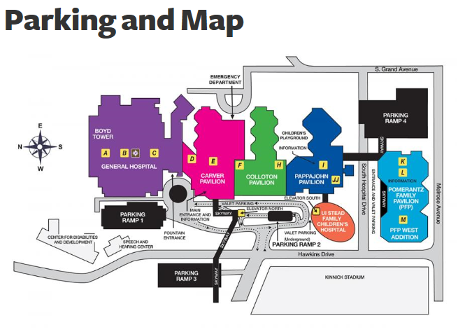
PARKING:
Ramp 2 is an underground ramp and is located off of Hawkins Drive. Take the elevator to Level 2 and follow the Skywalk to Elevator F.
The conference will take place in the East Room on the 8th Floor of the Roy Carver Pavilion. Please take Elevator F to Level 8. Turn right and follow signs to the East Room.

